1. Brief Overview

1.1 When Commercial Umbrella?
Commercial Umbrella is used when Quotes needed to be generated for an Insurance Policy which may be a new or existing policy. The name Umbrella signifies the fact that several coverages or liabilities are covered under a single policy.

1.2 Why Commercial Umbrella?
This web based application serves as a calculator for Agents to generate quotes for their clients, even save all the details entered for later retrieval, further from the same data the renewal calculation can also be generated and quoted. In short this application allows the user to select all the coverages covered under a policy and one by one the details for each coverage would be gathered and finally all details would be displayed in a summary screen.

1.3 Commercial Umbrella Users:
Commercial Umbrella application is supporting the following users:
- Underwriters – Both EA and IA underwriters (Internal Users).

EA (Exclusive) - Agents who are employees of Nationwide.
IA (Independent) – Agents who practice as a broker for Nationwide.

Note: All users come through Nationwide’s intranet or VPN can access this application.

1.4 Business Function of Commercial Umbrella Application:
The Key business functions provided by Commercial Umbrella are:
- Add Policies.
- Add or Remove coverages for policies.
- Save all the details of covearges.
- Generate Quotes or Summary screen.
- Maintain endorsement forms.

1.5 Basic Flow of Commercial Umbrella:
User will give all the details to the Agents for new Policy or Renewal. Agents will enter all the details in Commercial Umbrella web application. After agent enters all the required details for the policy the quotes would be generated in the summary screen, it would be available in a printable format.

Once the details are saved it can be retrieved at anytime for renewal or just for generating the quotes again with the help of the policy number.

2. Application Workflow

- Selection of Platform or Channel, effective date, end date, policy number, policy holder name, Agent name, Agent number and other stuff related to Policy information.
- Selection of Coverage(s).
- Enter details for each coverage selected
- Based on details entered and rates applicable to each states and constraints specific to each liability the Summary Screen is displayed with detailed information.
- Endorsement Forms are selected then via a link present in Summary Screen.

Let’s see each step in detail in following sections.

Step 1:

Login Screen
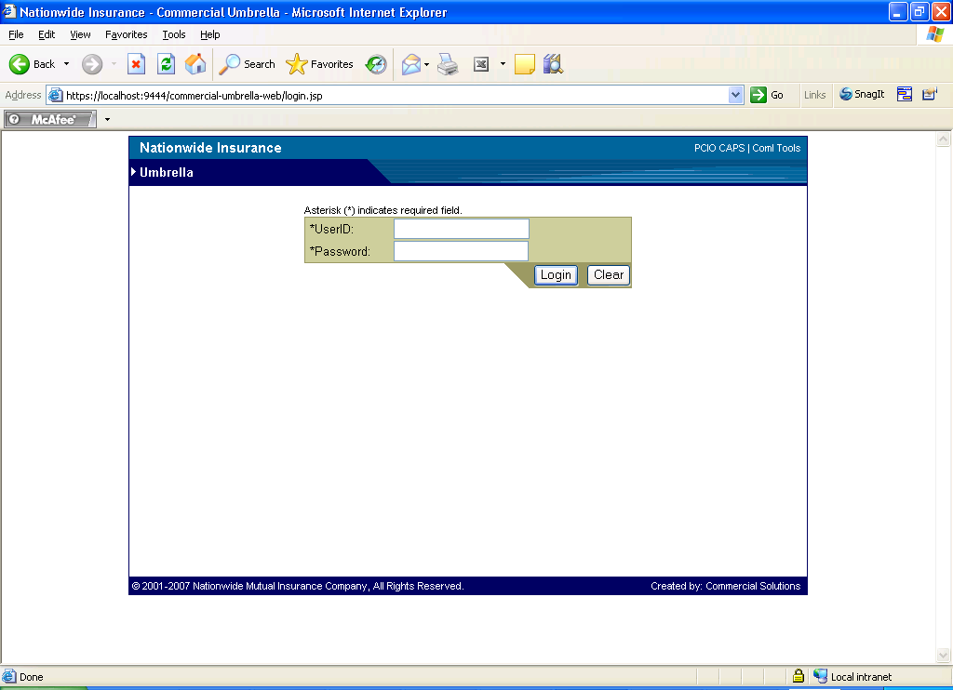

User Name: dayany
Password: *******

After successful login the Default page would get loaded as below.

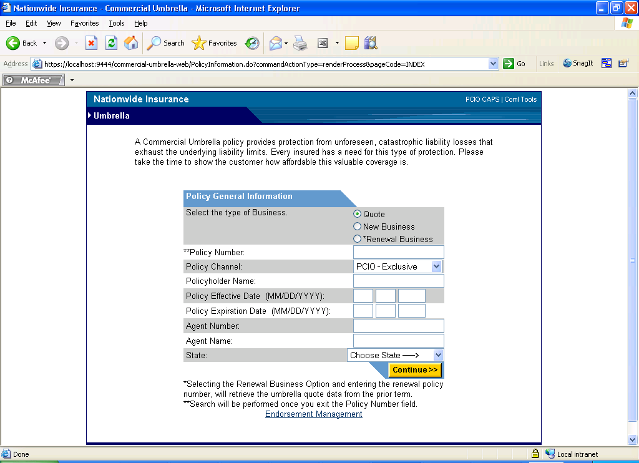

Explanation about Fields present in Default page.

- Select the type of Business (Radio button)
  - Quote ( This option is selected if policy is already entered and agent want to see just the quote that already exists)
  - New Business (This option is used when agent entering details for the first time)
  - Renewal Business (This option is to mention that the new policy no entered is a renewal policy number for an existing or expired policy)

- Policy Channel:

a. Select a channel from the drop down

- Policy Number
  - This is a 10 digit numeric field.
  - After entering 10 digit policy number and if user tabs out, the system will search the details for the policy number entered and loads up in the screen.
  - If policy number entered by the user doesn’t exist in the system, it alerts the user that the policy number doesn’t exists. 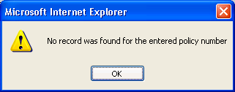

The Policy No entered has a 10 digits and has the following characteristic

Example if Policy No is: 6601234567

First 2 digits: 66 (Regional Office Code)
3rd digit: 0 (DEC number will get incremented for each renewal)
Remaining digits: 1234567 (Policy no)

- Policyholder Name:

This field holds the policy holder name.

- Policy Effective Date

a. This field holds the policy start date in MM/DD/YYYY format.
b. After entering effective date and tabbing out will result in auto populating the values of Expiration date with an interval of 1 year.

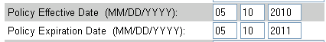

- Policy Expiration Date:

This field holds the policy expiration date in MM/DD/YYYY format.

- Agent Number:
  - Alphanumeric id of agent

- Agent Name:
  - Agent’s Name

- State:
  - Selects a state from drop down.

Pressing continue button would lead to next page.

Step 2:

Coverage Selection Page:

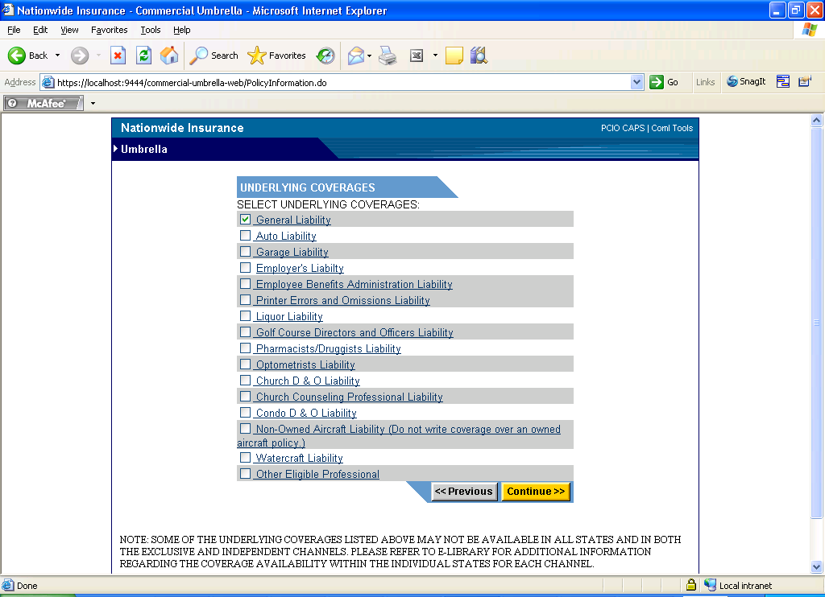

The user needs to select the coverages which he intends to take by selecting the check box before its name.

Clicking on any of the coverage title like (General Liability) would open up a help page as below.

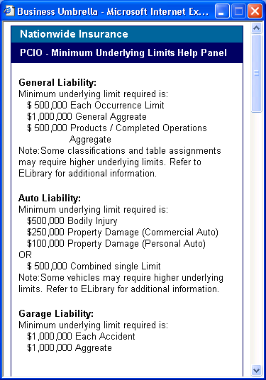

Clicking on Previous or Continue button would navigate back or forward respectively.

On pressing any of those buttons would actually save the details entered in current page.

General Points to Note:

- Most of the numeric fields in upcoming liability pages are validated in Java Script
- Java Script validation is done to check numbers are whole number.
- Alerts would be thrown appropriately if any validation fails.
- For both the channels the coverages would be same as of now.
- For most coverage if State selected is CA or NV, then the rate % field and Min Premium field would be editable. For other states these fields would be mostly read only.
- For each renewal the DEC number would be increased by 1.

Based on selection of coverages all the coverage details page would get loaded one by one in further proceedings.

Step 3:

General Liability:
As the name specifies it’s a general liability covering office premises, swimming pool, etc.
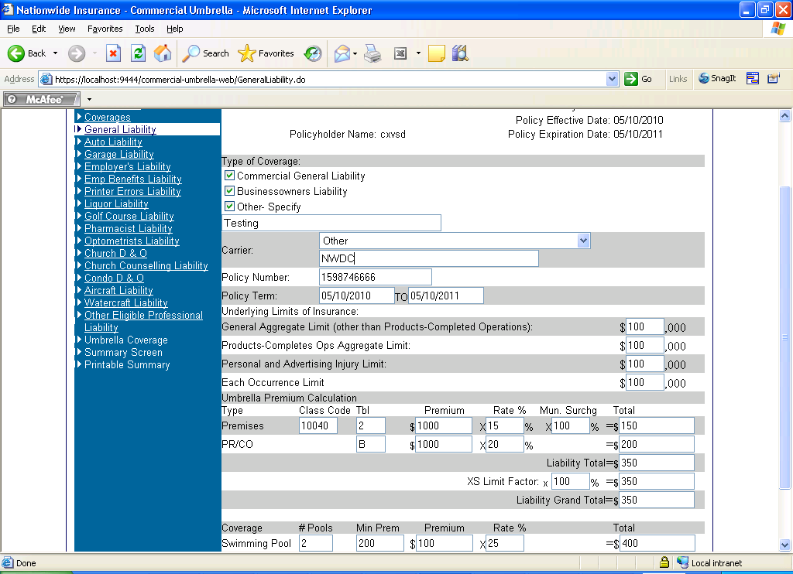

- Type of Coverages
    - Check box to select type of liability.
    - If Other is selected a Text box will appear to Specify the Name of liability.

- Carrier
  - Drop down box with list of Insurance companies belonging to Nationwide and user has to select one.
  - If Other is selected as a option, a text box would appear below as shown.

- Policy Number
Numeric field to hold policy number
- Policy Term
  - Hold the Effective date and Expiry date of the policy
- General Aggregate limit
Numeric field for combined aggregate limit
- Products-Completes Ops Aggregate Limit
Numeric field
- Personal and Advertising Injury limit
Numeric field
- Each Occurrence limit
Numeric field
The Premises and PR/CO are the Categories for the General Liability

- Class Code
  - After entering a valid class code and tabbing out the Tbl, Rate field and Mun Surcharge would get Auto populated.

- Premium
A numeric field and tabbing out after entering data would help to calculate total for that category with the help of rate % entered.
11) Liability Total
Sum of all category total
- XS Limit factor * (data entered by user in %)
- Liability Grand Total
Takes the calculated value from
XS Limit factor * (data entered by user in %)
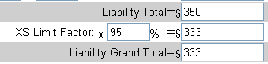

- For Swimming pool coverage user has to enter #Pools and Premium values the Min Premium and Rate would be loaded for the DB based on state selected. The calculation would works as 1) # Pools * Min Premium and 2) Premium * Rate %.
Comparing 1) and 2) the greater value would be used for Total

Note: If State Selected is CA or NV then Min Premium and Rate fields would be editable.

Pressing Previous or Continue would saves these data and navigate to previous or next page respectively.
Auto Liability:
This liability intends to cover Automobiles of commercial type like Light, medium and Heavy vehicles.
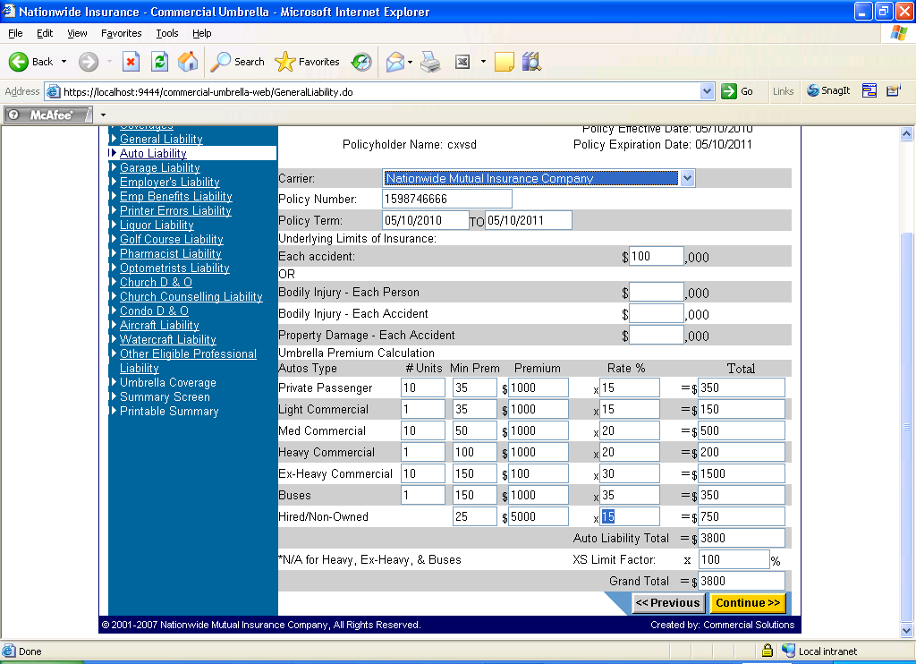

Underlying Limits of Insurance:
User can enter values in Each Accident (It’s the aggregation of all) OR enter values in Bodily Injury – Each Person, Bodily Injury – Each Accident, and Property Damage – Each Accident.

User has to enter #Units and Premium values, the Min Premium and Rate would be loaded for the DB based on state selected. The calculation would works as 1) # Units * Min Premium and 2) Premium * Rate %.
Comparing 1) and 2) calculation the greater value would be used for Total for each category.
XS Limit Factor = (data entered by user in %)
Grant Total = Auto Total * (XS Limit factor %)

Note: If State Selected is CA or NV then Min Premium and Rate fields would be editable.
Pressing Previous or Continue would saves these data and navigate to previous or next page respectively.
Garage Liability:
This liability is to insure the Garage and automobile in it.
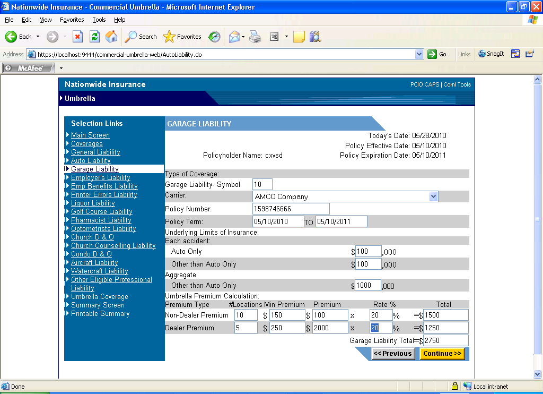

Garage Liability – Symbol
Each Accident (Limits for Each accident)
Auto and Other than Auto – Numeric Field
Aggregate (Overall Limit i.e. includes many accident)
Other than Auto Only – Numeric Field

The Non-Dealer Premium and Dealer Premium are the two categories.

User has to enter #Location and Premium values, the Min Premium and Rate would be loaded for the DB based on state selected. The calculation would works as 1) # Units * Min Premium and 2) Premium * Rate %.
Comparing 1) and 2) calculation the greater value would be used for Total for each category.
Note: If State Selected is CA or NV then Min Premium and Rate fields would be editable.
Garage Liability Total = Sum of the Total of both categories

Employer’s Liability:
Liability taken by Employer for its employees.

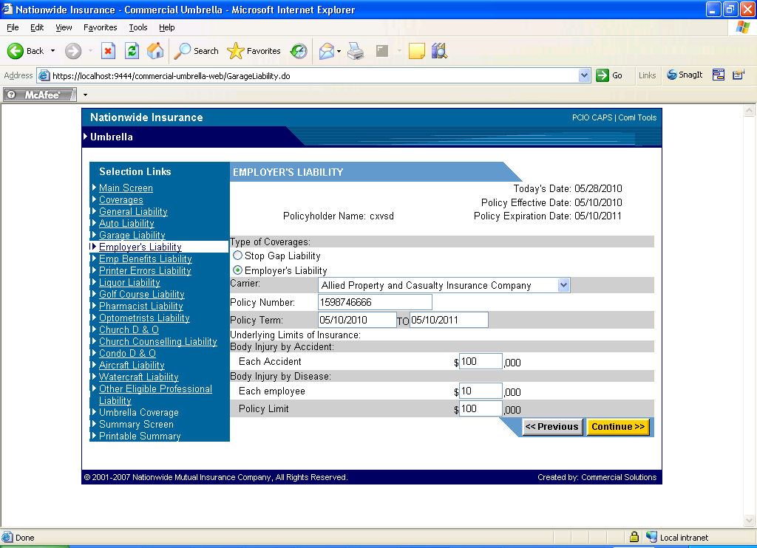

User has to select any one of the coverage from
Stop Gap Liability
Or
Employer’s Liability

Body Injury by Accident
Each Accident (Insurance limit for each accident)

Body Injury by Disease:
Each Employee (Insurance limit taken for each employee)
Policy Limit (The total policy limit for this liability)

Pressing Previous or Continue would saves these data and navigate to previous or next page respectively.

Employee Benefit Liability:
Liability for Employee benefit.
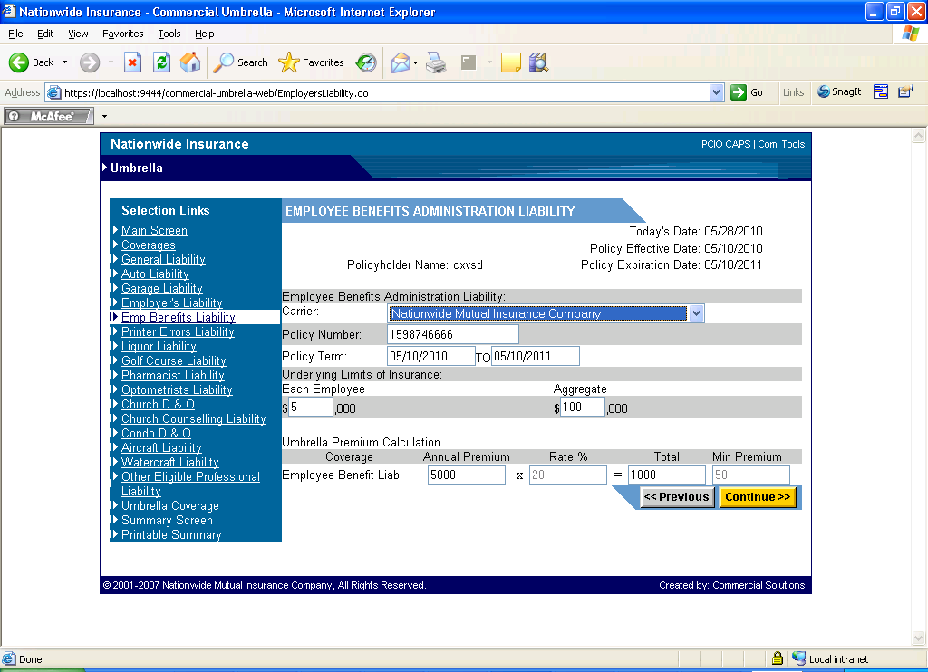

Each Employee (Insurance coverage for each employee)
Aggregate (Overall Coverage Limit)

Employee Benefit Liab is the only category under this coverage.

The Rate % and Min Premium would be loaded from the table and are not editable based on state selection

Calculation works as Rate% * Annual Premium the result would be compared with Min Premium which ever evolves as greater would be put in Total.

Pressing Previous or Continue would saves these data and navigate to previous or next page respectively.

Printer’s Errors and Omissions liability:
As you may know, business liability insurance covers losses related to bodily injury, property damage or advertising injury. But what happens, and who pays, when a printer neglects to catch a typographic error on a large order of engraved wedding invitations? Or when a plumbing repair fails and causes an entire office to be flooded?
Issues like these can be resolved with the purchase of errors and omissions insurance.

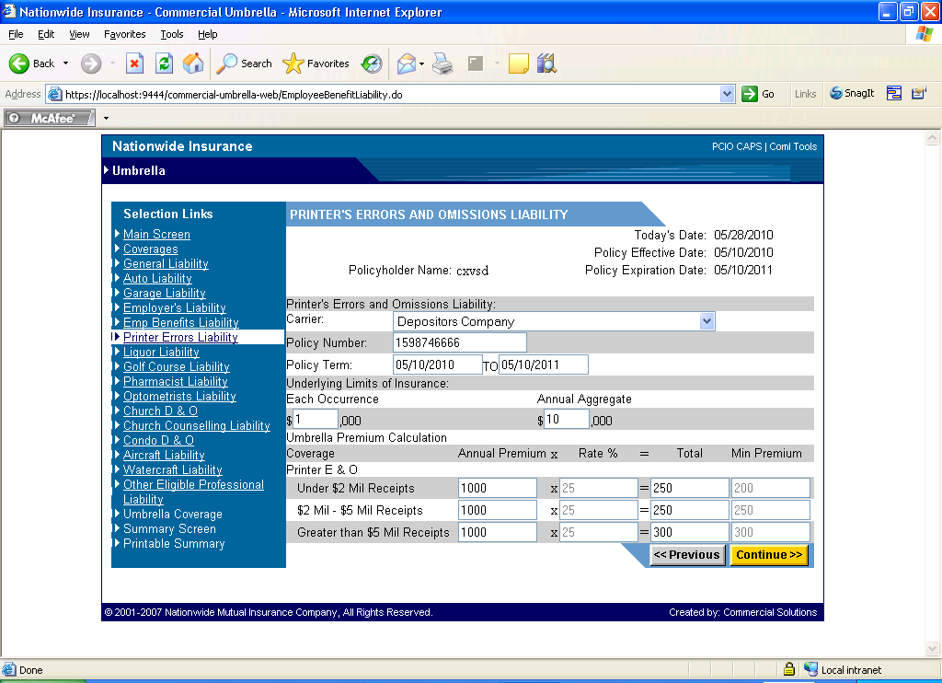

Each Occurrence (Coverage limit for each Occurrence)
Annual Aggregate (Annual Coverage limit)

Three categories are available under this coverage

Calculation works as Rate% * Annual Premium the result would be compared with Min Premium which ever evolves as greater would be put in Total.

Pressing Previous or Continue would saves these data and navigate to previous or next page respectively.

Liquor Liability:

It is a type of insurance which covers businesses in the event that claims related to liquor are made against the business. Most classically, such claims involve damages as a result of the actions of an intoxicated person, such as a lawsuit filed by someone involved in a crash caused by someone who was drunk.

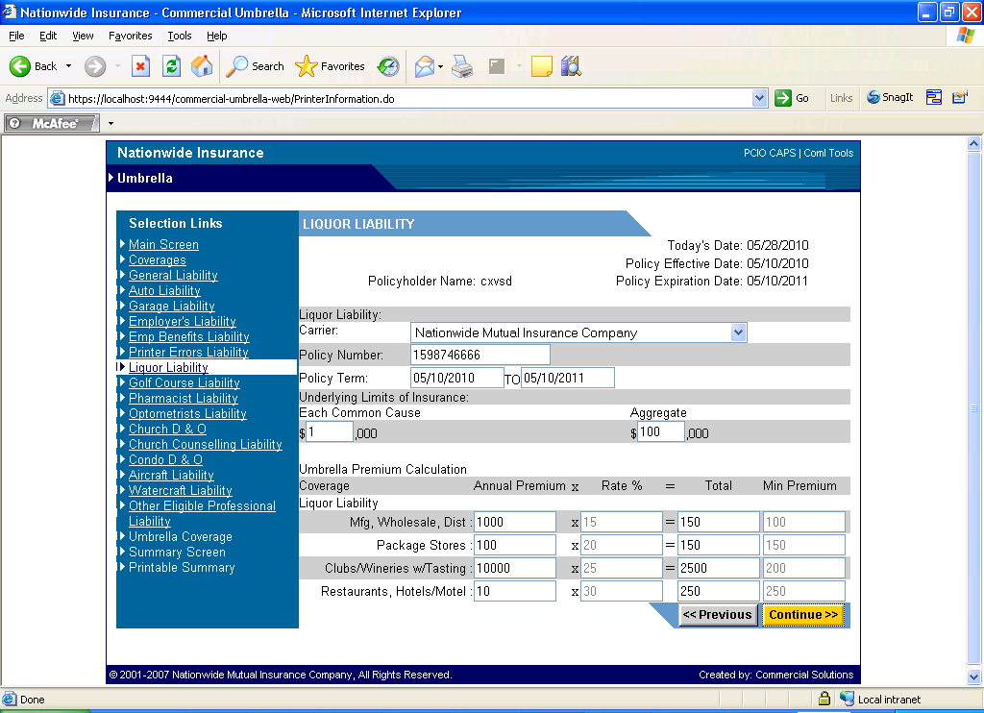

Each Common Cause (Limit for each occurrence)
Aggregate (Overall limit)

Four categories are available under Liquor Liability.

Calculation works as Rate% * Annual Premium the result would be compared with Min Premium which ever evolves as greater would be put in Total.

Pressing Previous or Continue would saves these data and navigate to previous or next page respectively.

Golf Course Directors and Officers Liability:

Coverage to claim against directors and officers for wrongful acts.

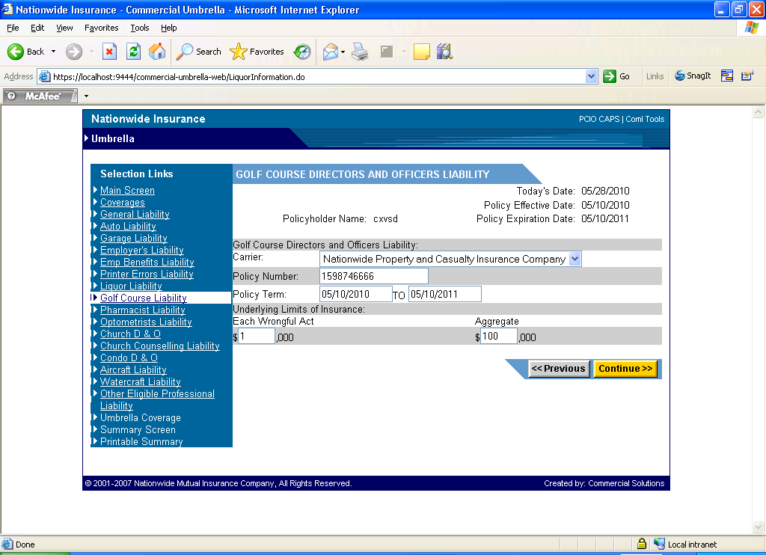

Each wrongful Act (Limit for each occurrence)
Aggregate (Overall Coverage)

Pressing Previous or Continue would saves these data and navigate to previous or next page respectively.

Pharmacists/Druggists Liability:

It is an insurance coverage against malpractice lawsuit sued against Pharmacist/Druggists.

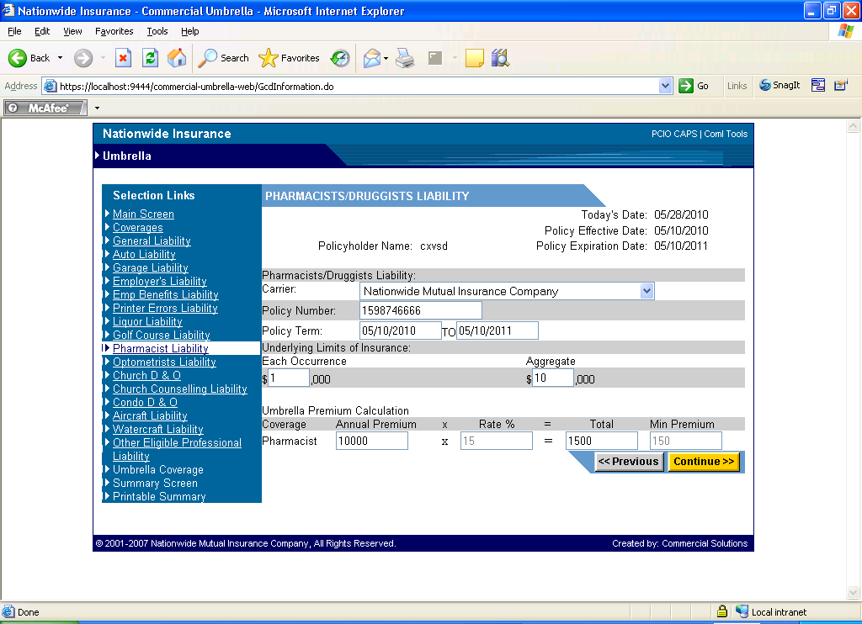

Each Occurrence (Limit for each occurrence)
Aggregate (Sum up of Overall coverage)

One category is available under this Liability.

Calculation works as Rate% * Annual Premium the result would be compared with Min Premium which ever evolves as greater would be put in Total.

Pressing Previous or Continue would saves these data and navigate to previous or next page respectively.

Optometrists Liability:

It is an insurance coverage against malpractice lawsuit sued against Optometrists

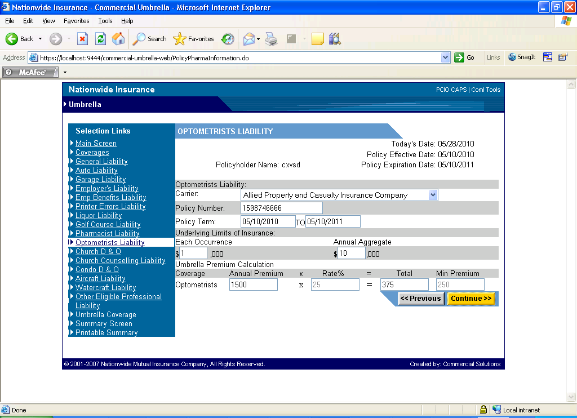

Each Occurrence (Limit for each occurrence)
Annual Aggregate (Sum up of Annual coverage)

One category is available under this Liability.

Calculation works as Rate% * Annual Premium the result would be compared with Min Premium which ever evolves as greater would be put in Total.

Pressing Previous or Continue would saves these data and navigate to previous or next page respectively.

Church D & O Liability:
This Liability insurance covers the directors and officers of a company, or to the organization(s) itself, to cover damages or defense costs in the event they suffer such losses as a result of a lawsuit for alleged wrongful acts while acting in their capacity as directors and officers for the organization.
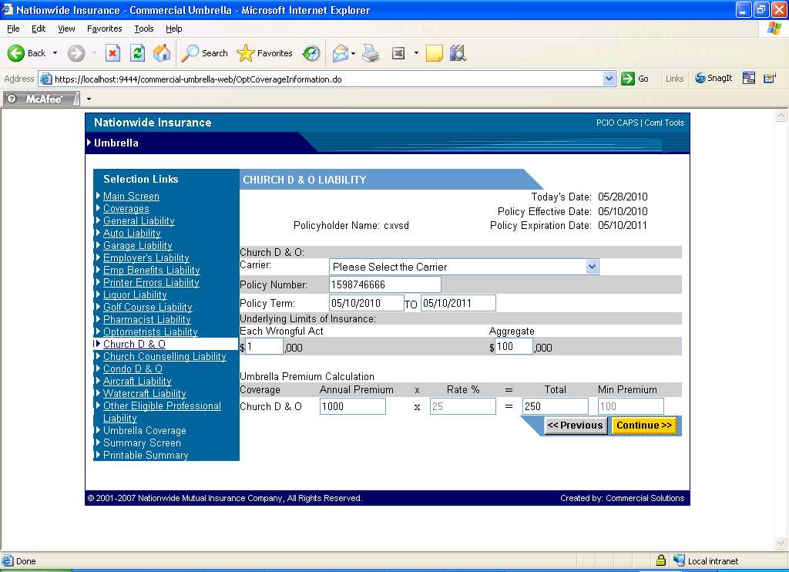
Each Occurrence (Limit for each occurrence)
Aggregate (Sum up of Annual coverage)

One category is available under this Liability.

Calculation works as Rate% * Annual Premium the result would be compared with Min Premium which ever evolves as greater would be put in Total.

Pressing Previous or Continue would saves these data and navigate to previous or next page respectively.

Church Counseling Professional Liability:

Insurance coverage for the camp or conference center, clergy, employees, and volunteers who counsel under the direction and control of Church Council and within the scope of their duties.
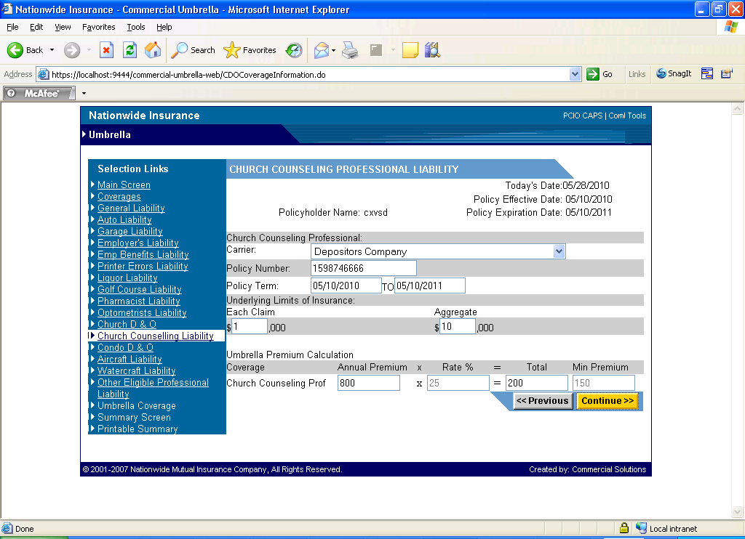

Each Claim (Limit for each occurrence)
Aggregate (Sum up of Annual coverage)

One category is available under this Liability.

Calculation works as Rate% * Annual Premium the result would be compared with Min Premium which ever evolves as greater would be put in Total.

Pressing Previous or Continue would saves these data and navigate to previous or next page respectively.

Condo D & O Liability:

The basic purpose of Condo Directors and Officers insurance is to protect directors and officers from claims made because of wrongful (or allegedly wrongful) acts or omissions made while acting in their individual or collective capacity on behalf of the homeowners association.

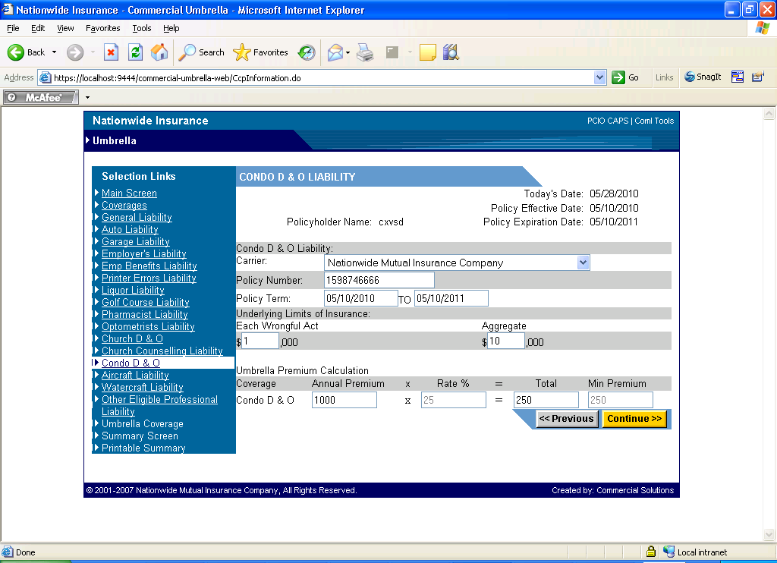

Each Wrongful Act (Limit for each occurrence)
Aggregate (Sum up of Annual coverage)

One category is available under this Liability.

Calculation works as Rate% * Annual Premium the result would be compared with Min Premium which ever evolves as greater would be put in Total.

Pressing Previous or Continue would saves these data and navigate to previous or next page respectively.

Non-Owned Aircraft Liability:

Coverage for you or your organization use an aircraft you or your organization do not own, even if you are only a passenger, and are not protected under the aircraft owner's insurance policy or elsewhere.

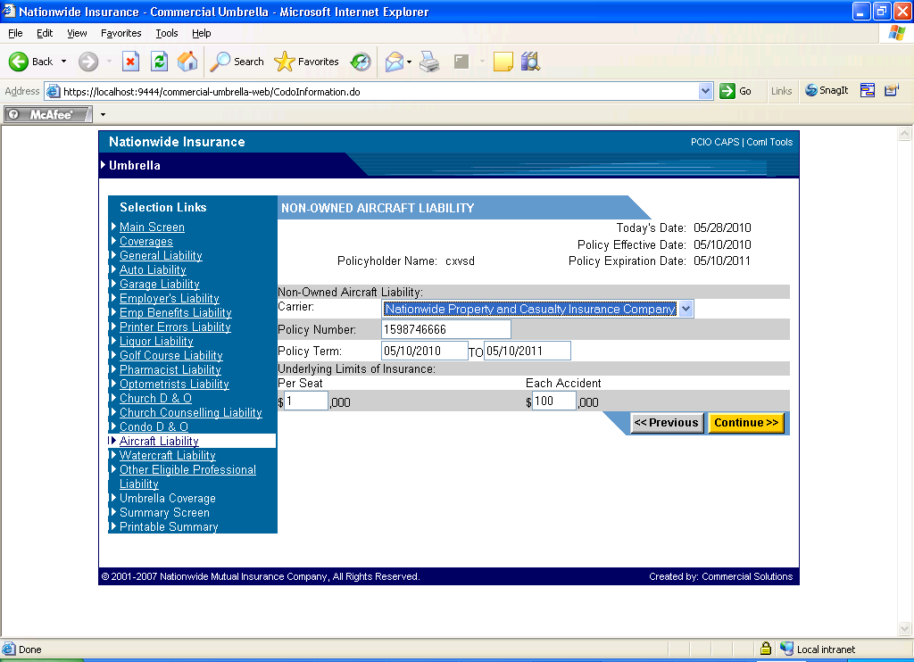

Per Seat (Coverage limit per seat)
Each Accident (Coverage limit for each accident)

Pressing Previous or Continue would saves these data and navigate to previous or next page respectively.

Watercraft Liability:

Coverage provides protection for legal liability because of an accident resulting from the ownership, maintenance, or use of the watercraft.

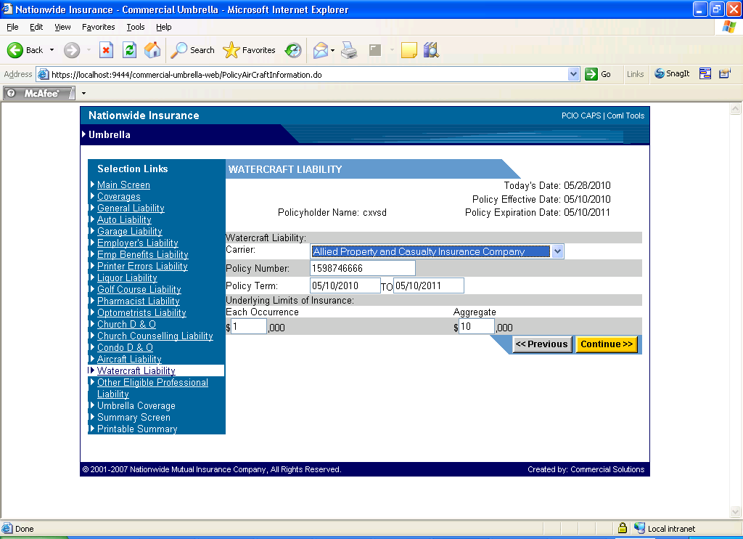

Each Occurrence (Coverage Limit for each occurrence)
Aggregate (Aggregate limit)

Pressing Previous or Continue would saves these data and navigate to previous or next page respectively.

Other Eligible Professional Liability:

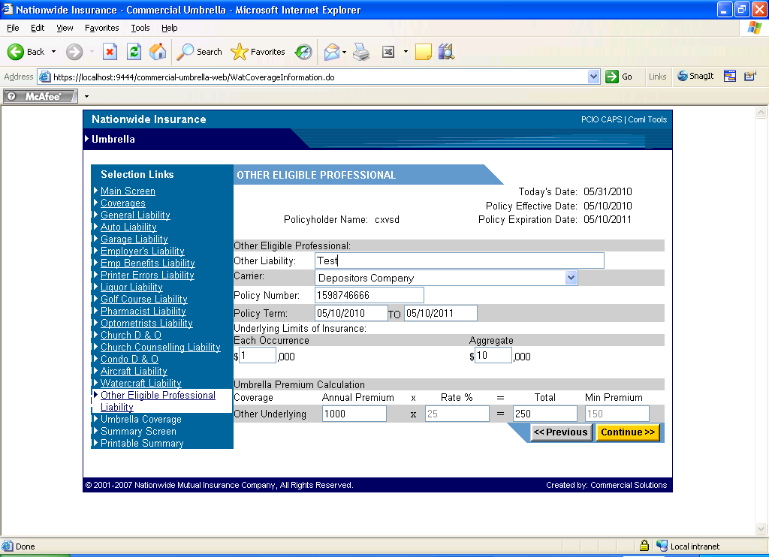

Each Occurrence (Limit for each occurrence)
Aggregate (Aggregate coverage limit)

One category is available under this Liability.

Calculation works as Rate% * Annual Premium the result would be compared with Min Premium which ever evolves as greater would be put in Total.

Pressing Previous or Continue would saves these data and navigate to previous or next page respectively.

Umbrella Coverage’s:

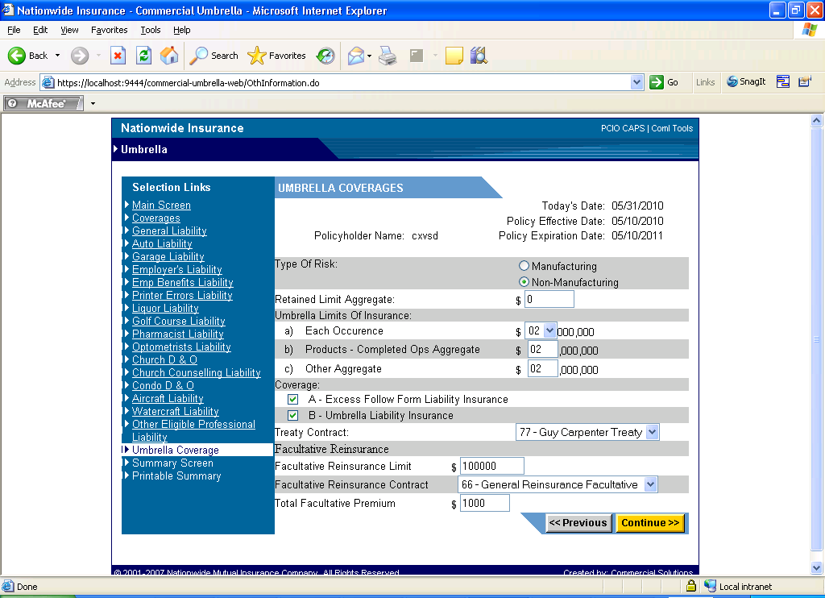

User has to select whether the policy belong to Manufacturing or Non-Manufacturing in the radio button provided.

Retained Limit Aggregate provides coverage for damages and defense costs that exceed the each occurrence limit of the underlying insurance

Each Occurrence (Limit for each occurrence – in million).

Coverage:

Excess Follow Form Liability Insurance is a provision that functions much like a deductible. The insured retains, or is personally responsible for, losses up to this self-insured retention.

Reinsurance is a means by which an insurance company can protect itself with other insurance companies against the risk of losses

Facultative Reinsurance Limit (Overall limit with the Re-insurer)
Facultative Reinsurance Contract (Reinsurer’s name)
Total Facultative Premium (Premium paid to reinsurer)

Pressing Previous or Continue would saves these data and navigate to previous or next page respectively.

Step 4:

Summary Screen:

In this screen all the details entered previously for all the liability would be presented in a summary format.

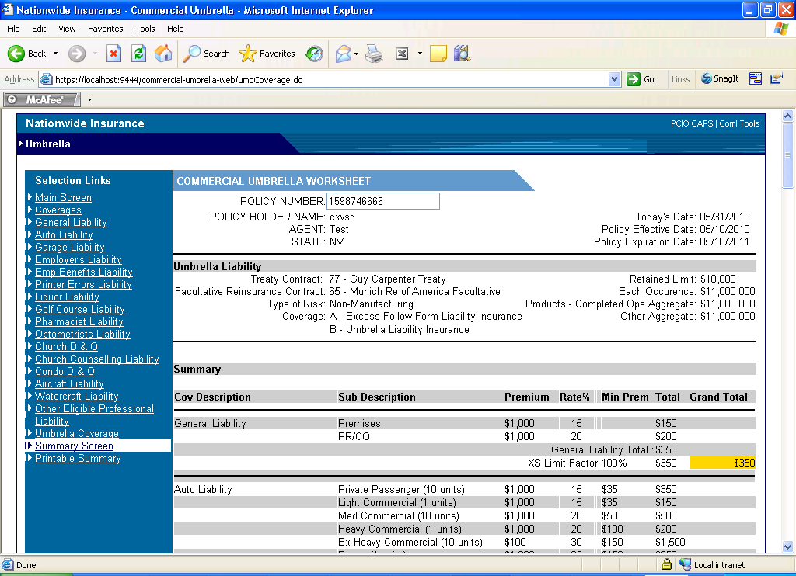

If we further scrolls down we could see several links.

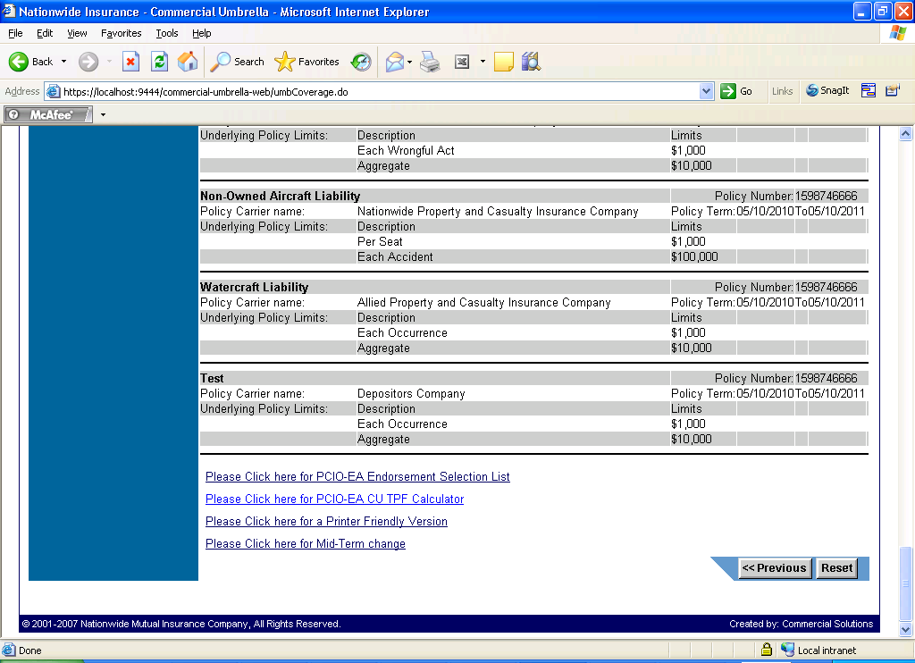

Step 5:

- Please click here for PCIO-EA Endorsement Selection List

This link opens the page where Endorsement forms which needed to be added to this policy would get displayed. User has to select the needed endorsement forms in the following page and finally it would get displayed in the summary screen.

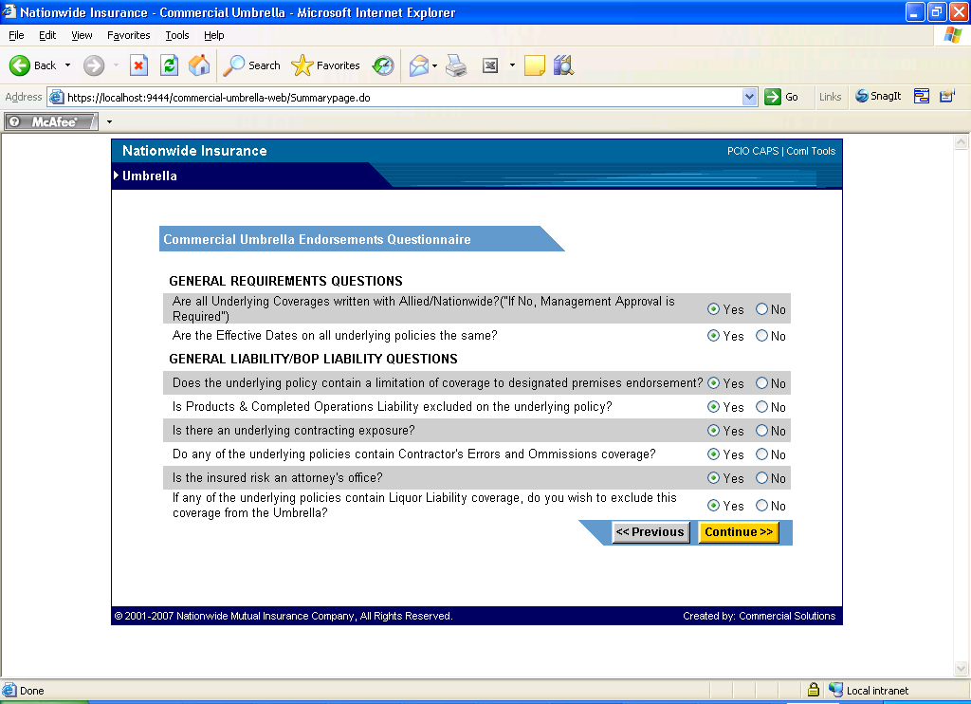

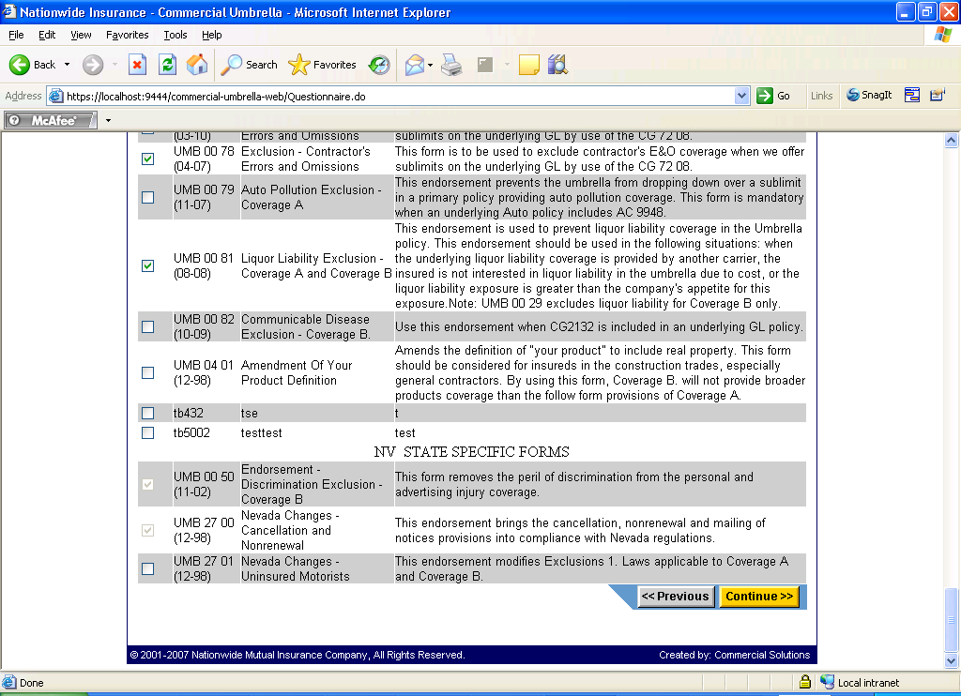

On pressing Continue, the forms selected here would get added in summary screen.

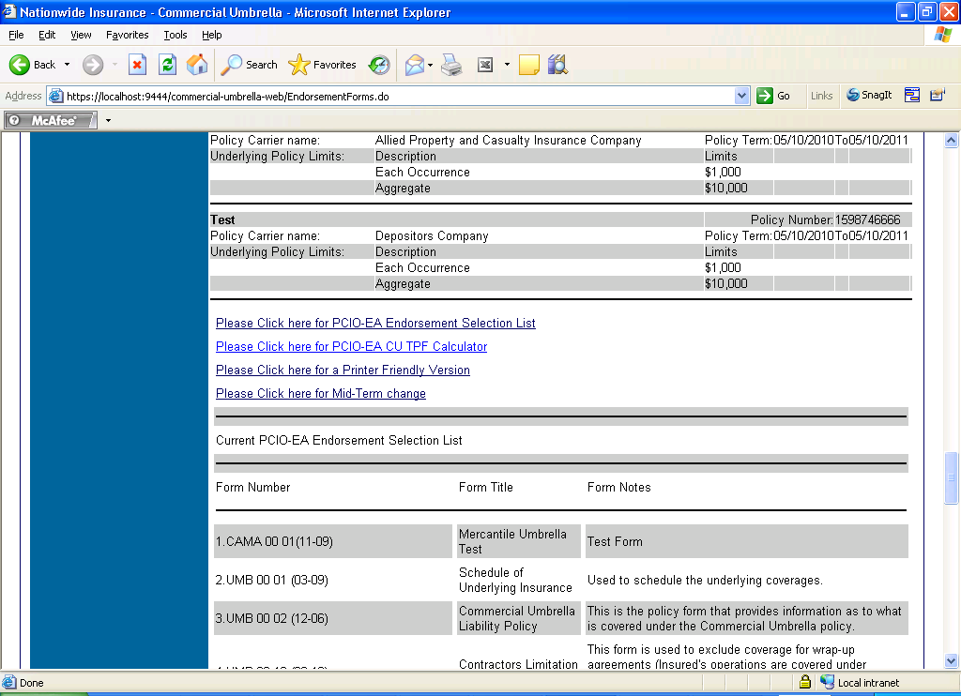

- Please click here for PCIO-EA CU TFP Calculator]

This link will open up the TFP Calculator.

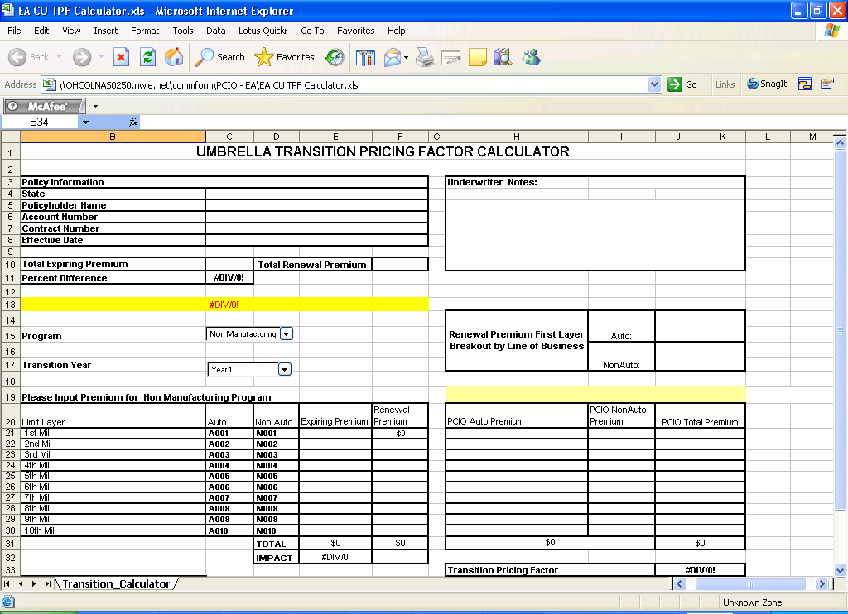

- Please click here for Printer friendly page will open up the summary screen in printer friendly page.

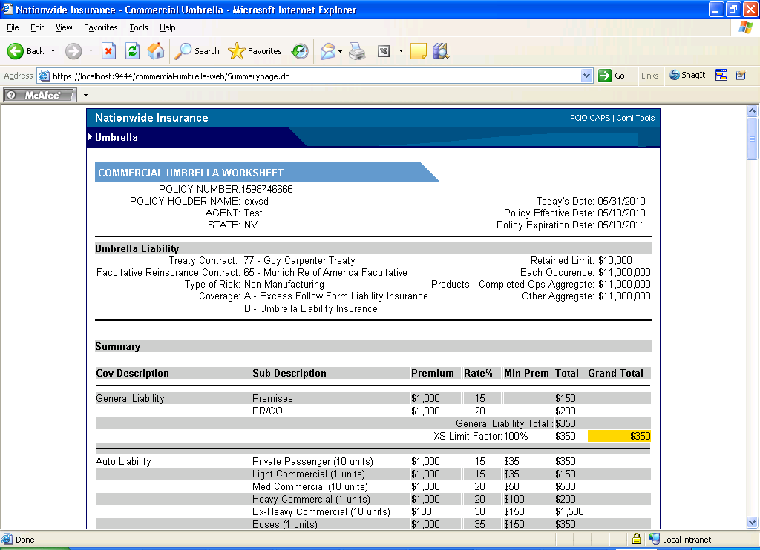

- Please click here for Mid Term – Charge.

Clicking this link will open up a calculator tool which would give the mid term charge calculated for the date which we have entered.

Policy effective date and Expiration date would be already present. We need to enter the mid term date in the Effective date of change column and press the Calculate midterm button to get the overall calculated value.
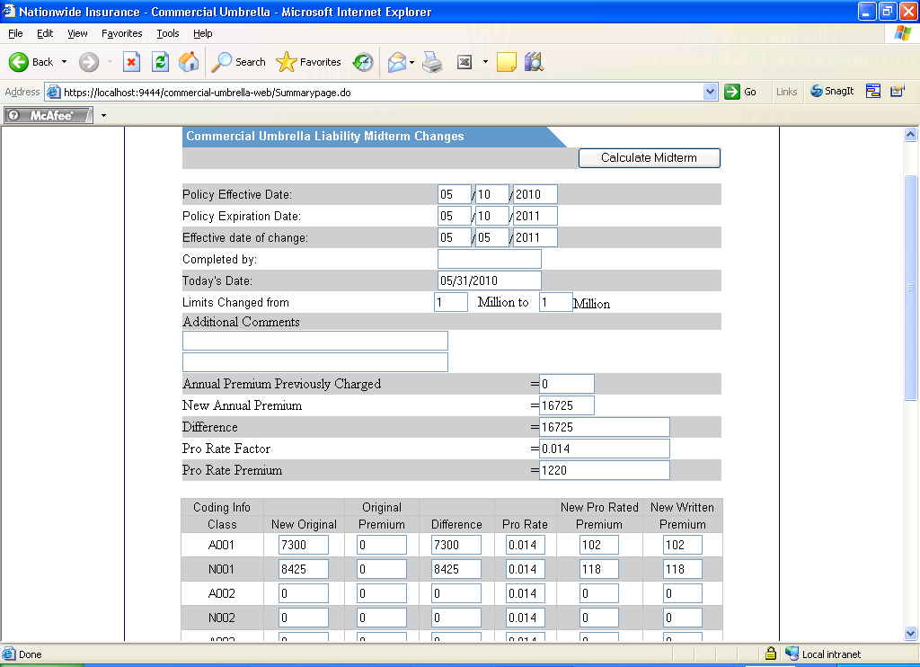

In the summary screen, we might have seen a Link to add endorsement forms. These forms present here were added in the DB by a separate user interface called Endorsement Management. The link would be available in the first page, Default page.

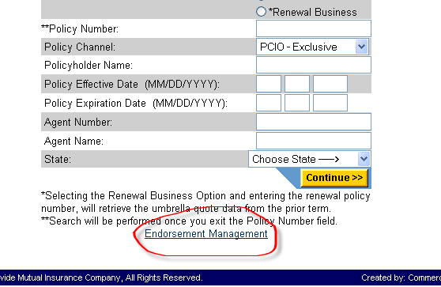

Clicking on the link would open up the Main page of Endorsement.

Main Page:

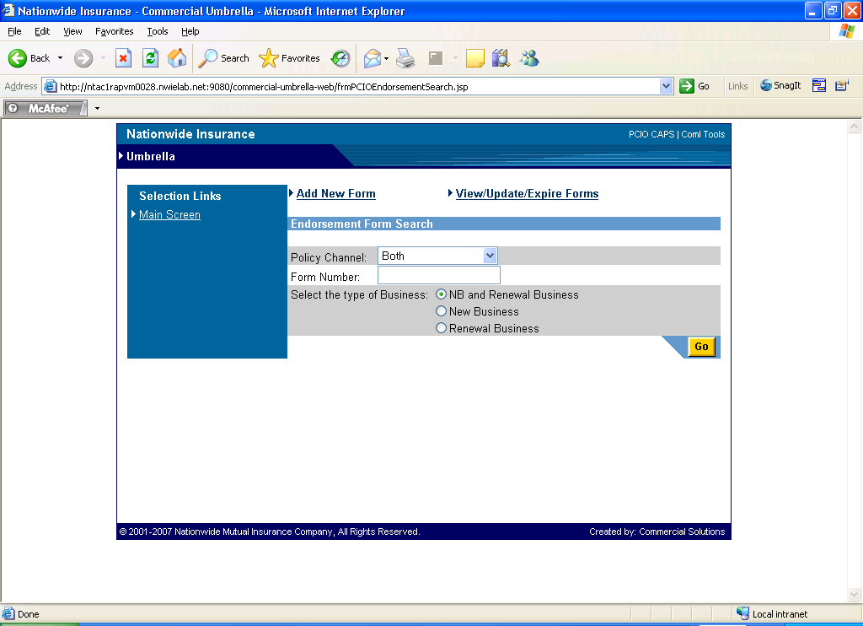

Users have to select Policy Channel, Form Number and Type of Business and pressing Go button would help in searching a Endorsement form.

The main page is page which gets loaded once the View/Update/Expire Forms link is clicked.

NB stands for New Business.

- Entering Form number as UMB 00 01

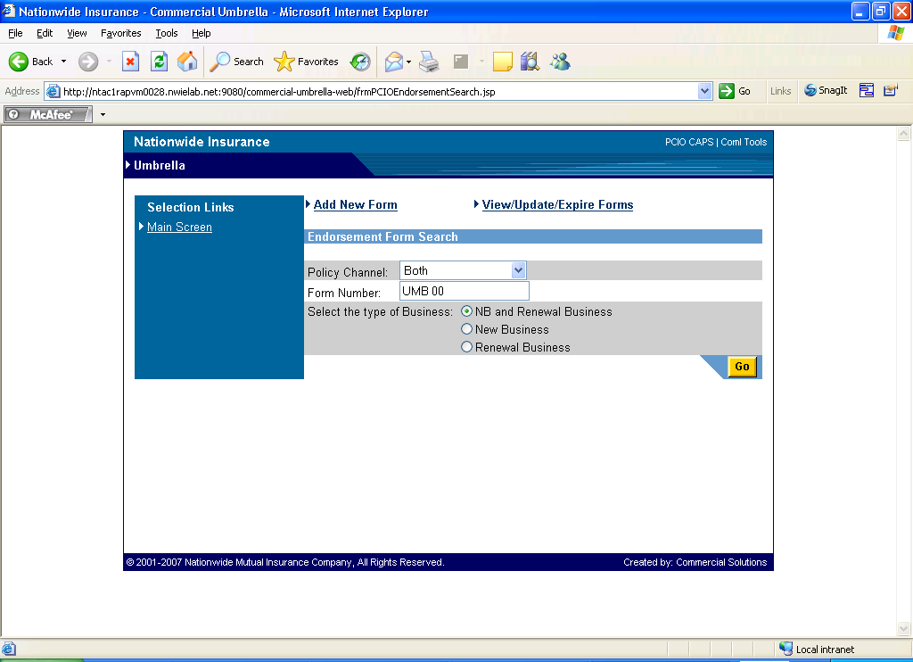

2) The search results would be displayed after pressing Go button.

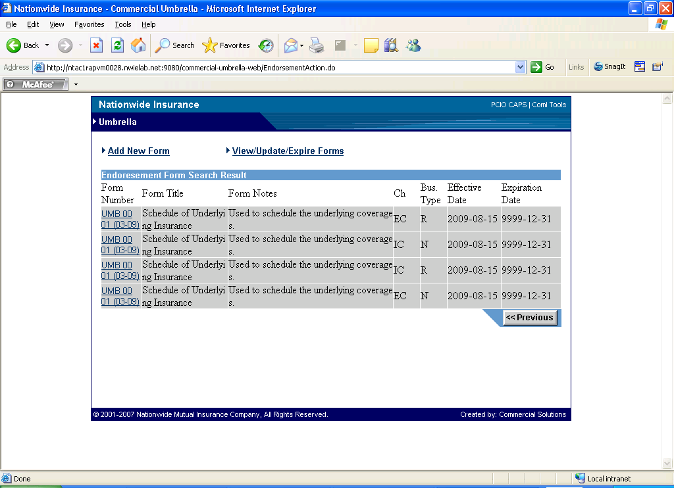

- Clicking on the Form Number, a link would open up the Form details.

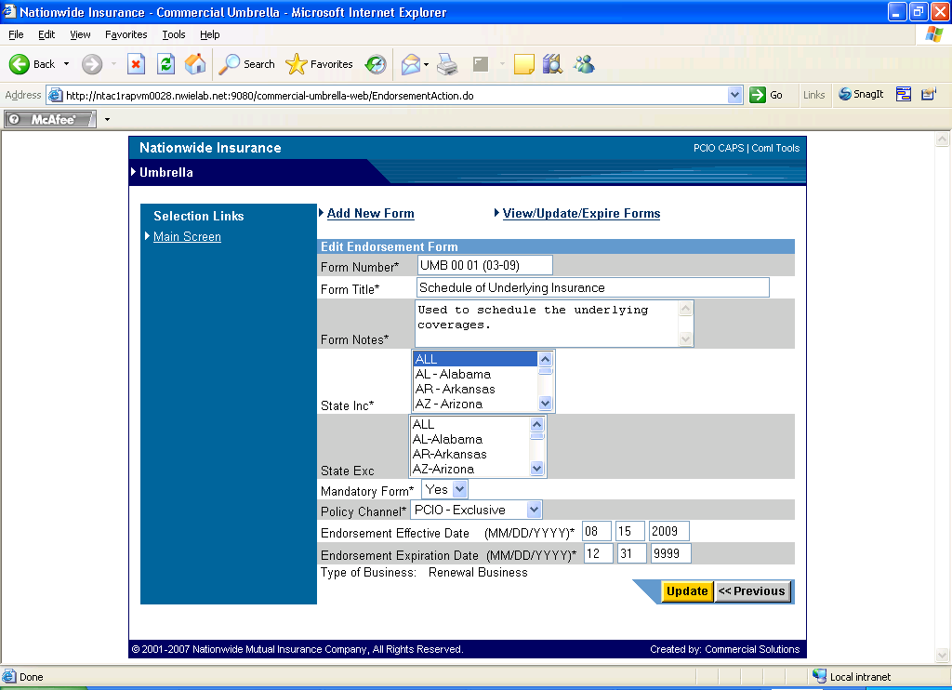

User needs to edit the fields and pressing Update would save these details.

Clicking Add New Form would open the Adding new form page.

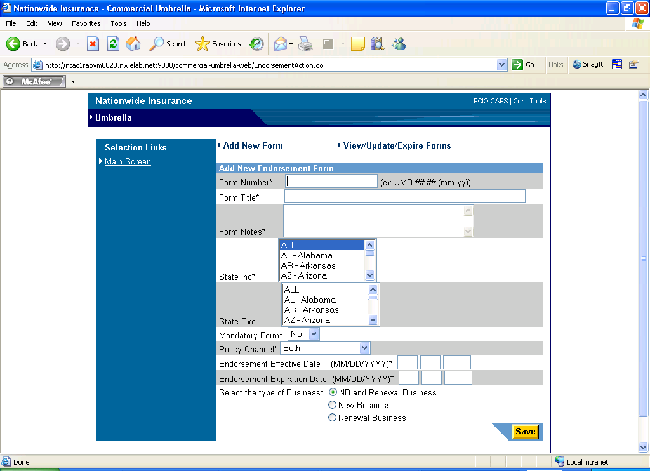
Form Number: The format is UMB ## ## (mm-yy))

Form Title: Form Title text field

Form Notes: Details about the Form, text field.

State Inc*: Select the states to be included.

Stats Exc*: Select the states to be excluded.

Mandatory Form: (Y/N) selecting YES would make this form mandatory by pre checking it in the Endorsement form page which would come after the summary screen for the channel it has been selected.

Effective Date: date format (form would be enabled from this date)

Expiration Date: date format (form would be expired from this date)

Type of Business: NB – New business.

Pressing Save would save these details in DB.

